**Node 2 => JDK 8 and maven**

* On the jenkins agent we would require jdk 17 and for the project game of life we would require jdk8
* On the node2 lets create a new user called as devops, give sudo no password access
* enable password based authentication

sudo vi /etc/ssh/sshd_config

# Change password Authentication to yes

sudo systemctl restart sshd

* Install jdk 8 and jdk 17

sudo apt update

sudo apt install openjdk-8-jdk openjdk-17-jdk -y

sudo apt install maven -y

* Now execute java -version  
  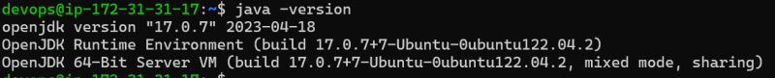
* Lets configure JDK 17 and JDK 8 paths in tools section of jenkins  
  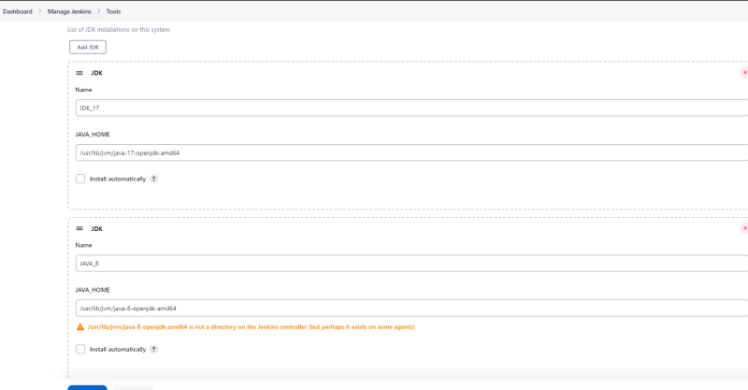
* Now add node2 to jenkins  
  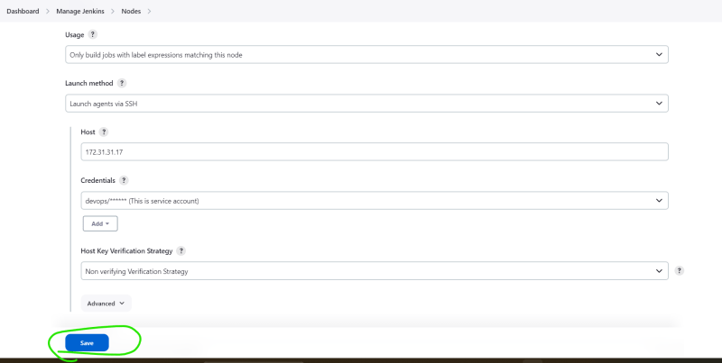  
  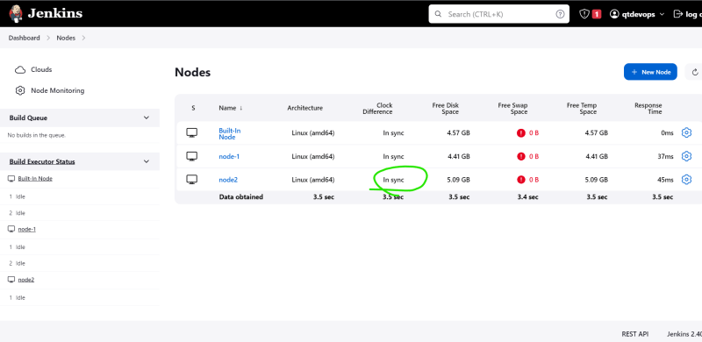
* Now lets try building game of life  
  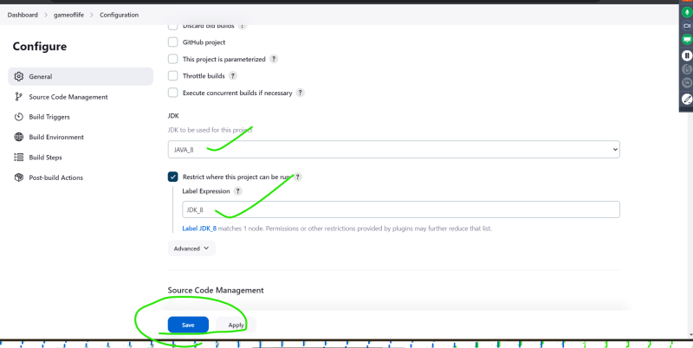  
  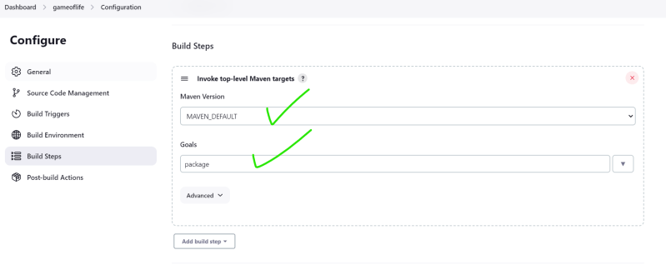  
  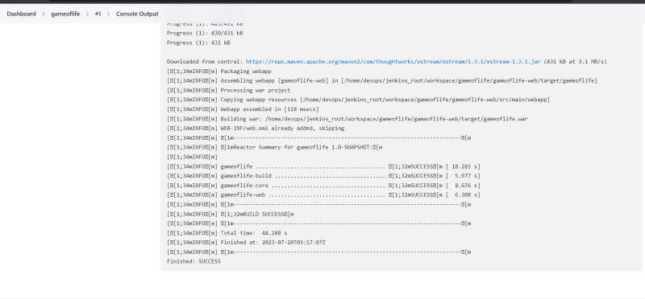
* Now lets add processing the test results **/surefire-reports/TEST-*.xml  
  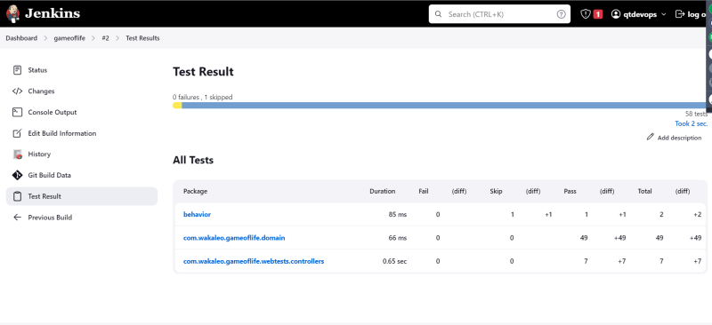
* As a result of this project build i get gameoflife.war which is called as artifact, lets configure jenkins to archive the artifacts  
  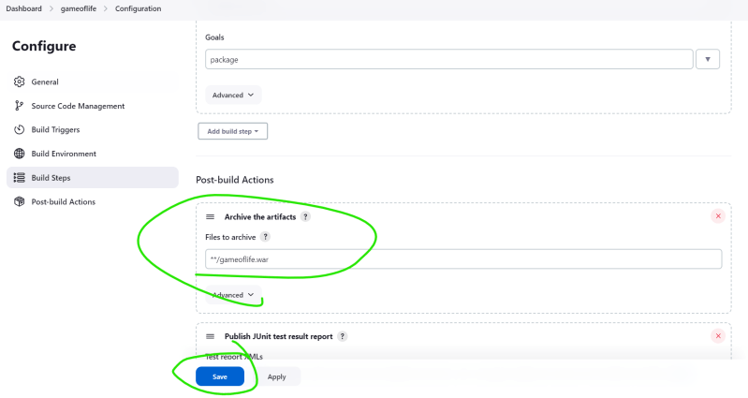  
  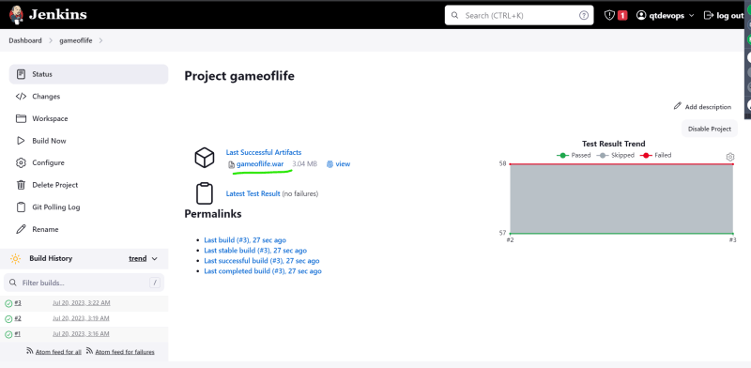
* Note: We have implemented the same for spring petclinic  
  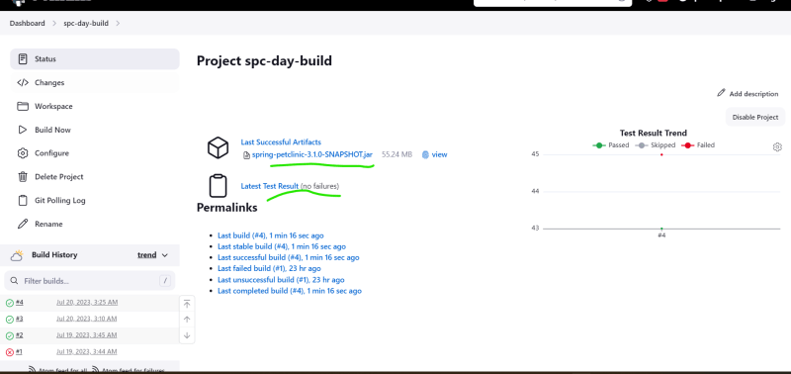
* Note: The health of the builds is represented as weather in jenkins
  + cloudy means builds are failing
  + sunny means the builds are successful  
    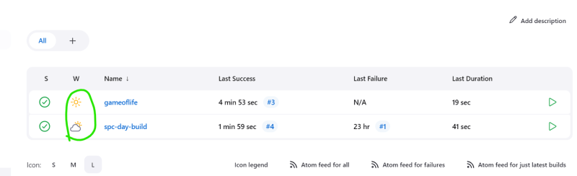

**Node 3: Executing dotnet project on jenkins**

* For agent we required jdk 17
* Create an ec2 instance with size 20 GB
* install dotnet 7 sdk for running nop comerce
* <https://learn.microsoft.com/en-us/dotnet/core/install/linux-ubuntu-2204> for installation instructions

sudo apt-get update && \

sudo apt-get install -y dotnet-sdk-7.0

dotnet --help

* to build the dotnet project we need to restore nuget packages

# dotnet restore <path of project or sln>

# For night builds

# dotnet build -c "Release" <path of project or sln>

# For day builds

# dotnet build -c "Debug" <path of project or sln>

dotnet restore src/NopCommerce.sln

dotnet build -c Release src/NopCommerce.sln